# Development Tools

Sharepoint Framework uses [Sass](http://sass-lang.com/) as the CSS pre-processor.

[Grunt](http://gruntjs.com/) is a popular tool used to automate common tasks like compiling [Sass](http://sass-lang.com/) files to CSS, making JavaScript files smaller so they load in less time, and compressing images to smaller file size.

Visual Studio

**Package Management:**

NuGet

<https://docs.microsoft.com/zh-cn/nuget/quickstart/install-and-use-a-package-in-visual-studio>

https://docs.microsoft.com/en-us/nuget/quickstart/install-and-use-a-package-in-visual-studio

sharepoint Client-side development Tools

Yeoman

Gulp

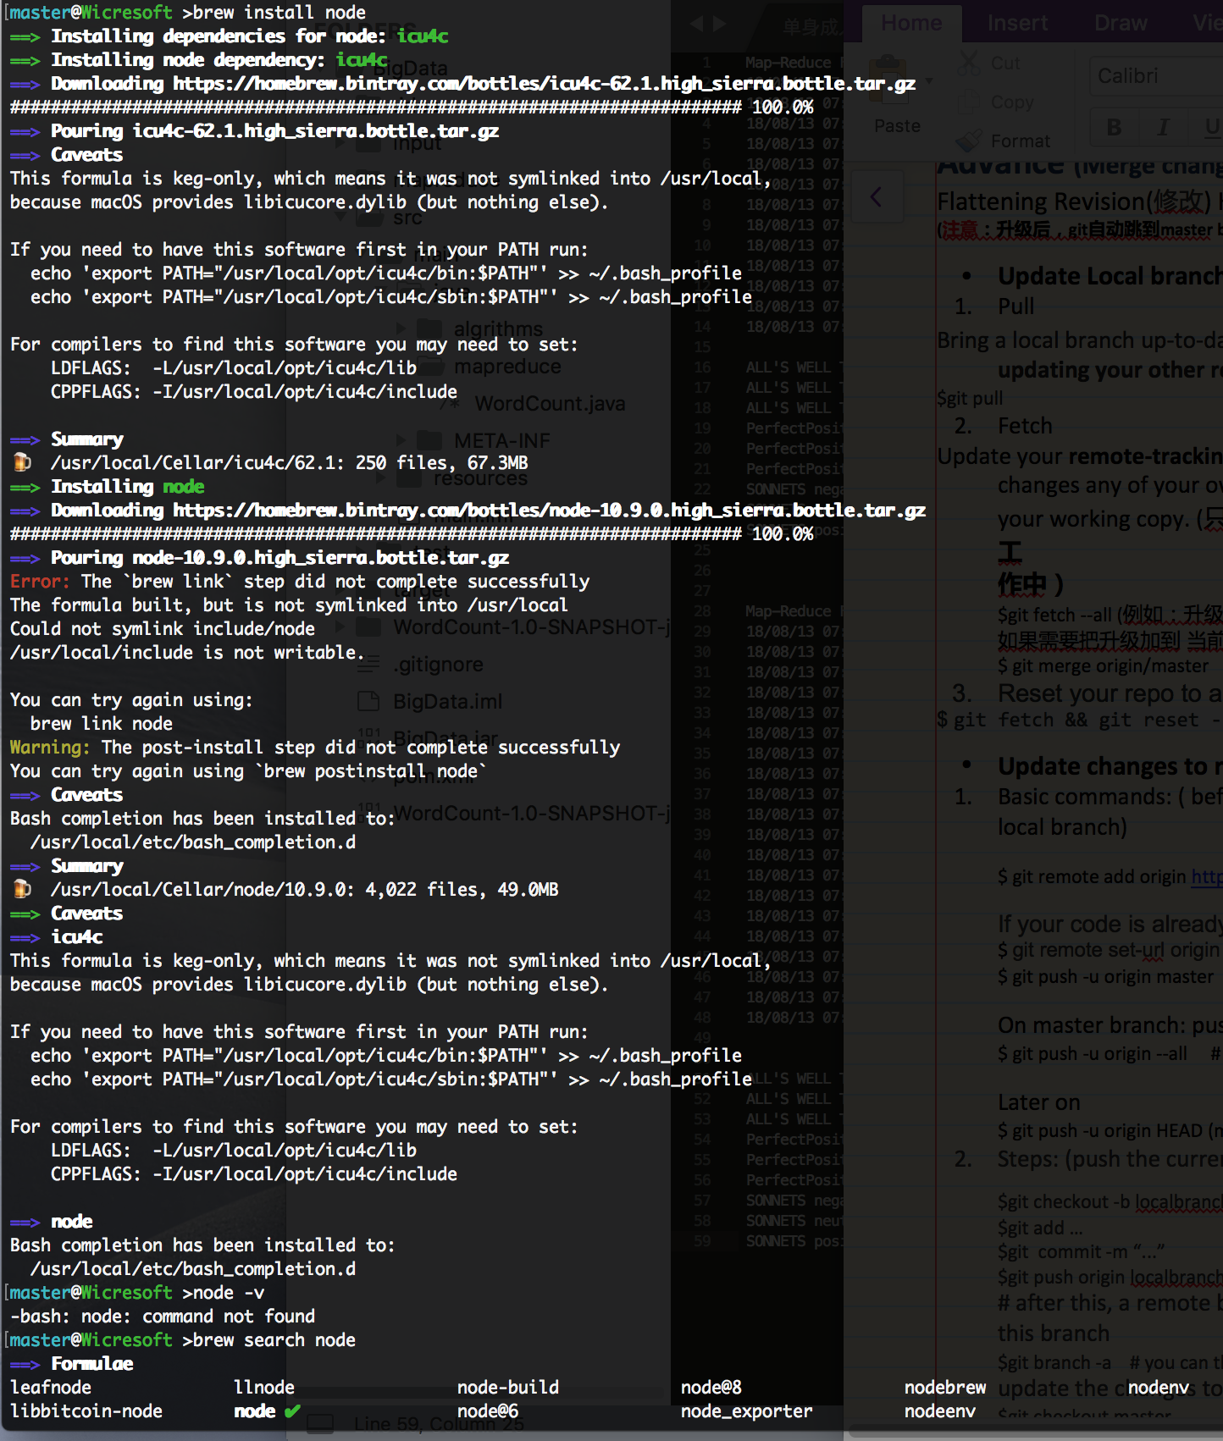

参考：<https://medium.com/@katopz/how-to-install-specific-nodejs-version-c6e1cec8aa11>

Brew unlink node

Brew install node@8

brew uninstall node